NICHOLAS MCGEGAN, CONDUCTOR
631 words
~
Music Director Laureate, Philharmonia Baroque Orchestra and Chorale
Principal Guest Conductor, Capella Savaria

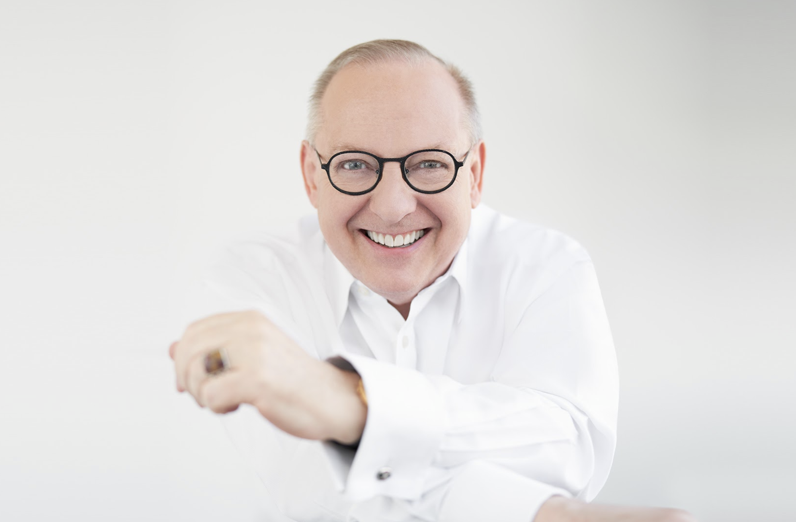
In his sixth decade on the podium, Nic McGegan — long hailed as “one of the finest baroque conductors of his generation” (The Independent) and “an expert in 18th-century style” (The New Yorker) — is recognized for his probing and revelatory explorations of music of all periods. He is Music Director Laureate of Philharmonia Baroque Orchestra and Chorale and Principal Guest Conductor of Hungary’s Capella Savaria.

Best known as a Baroque and Classical specialist, McGegan’s approach — intelligent, infused with joy, and never dogmatic — has led to engagements with major orchestras, opera houses, and international festivals across the U.S., U.K., and Europe.

Highlights of his 23/24 orchestral bookings include performances at the Aspen Music Festival and School; leading the Cleveland Orchestra in a program of Mozart and Mendelssohn at the 2023 Blossom Music Festival; a return to the Hollywood Bowl in a “Mozart Under the Stars” concert with the Los Angeles Philharmonic; two programs with the Bay Area’s Cantata Collective; engagements with the Detroit Symphony, Sarasota Orchestra, and Rhode Island Philharmonic; and performances of Handel’s Messiah with the Philadelphia Orchestra; Calgary Philharmonic; and the Grand Rapids, Edmonton, and New Jersey Symphonies.

On the operatic front this season, McGegan will conduct performances of two Handel operas: L’Allegro, il Penseroso ed il Moderato at the Curtis Institute of Music, and Giulio Cesare at the Blackwater Valley Opera Festival in Lismore, Ireland, as well as concert performances of Deborah with the NDR Radiophilharmonie in Herrenhausen and Göttingen, Germany.

McGegan’s prolific discography includes more than 100 releases spanning five decades. Having recorded over 50 albums of Handel — two of which received the U.K.’s prestigious Gramophone Award — McGegan has explored the depths of the composer’s output with a dozen oratorios and close to 20 of his operas. Since the 1980s, more than 20 of his recordings have been with Hungary’s Capella Savaria on the Hungaroton label, including groundbreaking recordings of repertoire by Handel, Monteverdi, Scarlatti, Telemann, and Vivaldi. McGegan also released two albums with the Swedish Chamber Orchestra under the BIS label: Josef Mysliveček’s complete music for keyboard with soloist Clare Hammond; and an album of early horn concertos with soloist Alec Frank-Gemmill. His extensive discography with Philharmonia Baroque includes two GRAMMY nominations, for Handel’s Susana and Haydn’s Symphonies 104, 88, and 101. Recent releases include an album of Mozart violin concertos with violinist Gil Shaham and the SWR Symphonie Orchester, and a recording of Mozart’s double concertos with violinist Zsolt Kalló and Capella Savaria.

With Cantata Collective, McGegan has released the first volume in an ongoing initiative to record all of Bach's Cantatas, which received critical praise from Early Music America and American Record Guide. McGegan and Cantata Collective have also announced a new partnership with AVIE Records to record Bach’s six choral masterpieces — the St John and St Matthew Passions, Mass in B Minor, Christmas and Ascension Oratorios, and the Magnificat — over the next five years. The first album in this ambitious project, the St John Passion, was released in May 2023.

Mr. McGegan is committed to the next generation of musicians, frequently conducting and coaching students in residencies and engagements at Yale University, the Juilliard School, Harvard University, the Colburn School, Aspen Music Festival and School, Sarasota Music Festival, and the Music Academy of the West.

English-born, McGegan was educated at Cambridge and Oxford. He was made an Officer of the Most Excellent Order of the British Empire (OBE) “for services to music overseas.” Other awards include the Halle Handel Prize; the Order of Merit of the State of Lower Saxony (Germany); the Medal of Honour of the City of Göttingen; and a declaration of Nicholas McGegan Day by the Mayor of San Francisco, in recognition of his work with Philharmonia Baroque.

For more information, visit nicholasmcgegan.com or visit his Facebook page at facebook.com/nicholasmcgegan.

Last updated: May 2023

